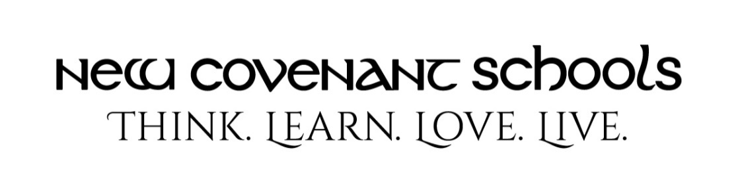
Upcoming Performances and Concert Dress Requirements for Middle School Students

Below are the Middle School performances for the 2022-2023 school year. Attendance and concert dress will be required:
Lessons & Carols - Monday, December 12, 2022
Spring Concert - Monday, May 22, 2023

Required Dress:
Lessons & Carols Dress uniform for boys and girls. Boys must wear long Flynn & O’Hara pants (NO shorts). Girls are required to wear black tights and black Mary Jane or black ballet flats in addition to the dress uniform.
Spring Concert: Regular dress uniform for boys and girls.

