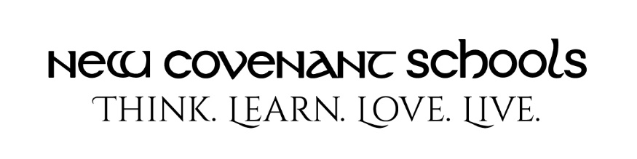
School of Dialectic Uniform Guide 2021-2022: 5 - 8th Grade Girls

Monday & Wednesday (non-dress days)
- NCS cardinal polo, banded or non-banded bottom (must be tucked in if non-banded)
- Flynn & O’Hara khaki skort, skirt or pants
- Solid black or brown belt (if wearing pants)*
- NCS hooded sweatshirt, navy fleece jacket or Flynn & O’Hara navy button up cardigan. (Please ensure these are sized appropriately.)
- Sperry topsiders (boat shoes), Hush Puppies Tuft, Merrell Jungle Moc: all in brown or beige only.* Basic Mary Jane: black or navy, no heel, strap must go over foot not top of shoe.
Tuesday & Thursday (dress days)
- Flynn & O’Hara blue oxford blouse (must be tucked in)
- Flynn & O’Hara blackwatch plaid skirt or kilt
- NCS navy fleece jacket or Flynn & O’Hara navy button up cardigan. (Please ensure these are sized appropriately.)
- Sperry topsiders (boat shoes), Hush Puppies Tuft, Merrell Jungle Moc: all in brown or beige only.* Basic Mary Jane: black or navy, no heel, strap must go over foot not top of shoe.
Friday (casual day)
- Any NCS issued T-shirt or NCS sports team issued jersey
- Flynn & O’Hara khaki skort, skirt or pants
- Solid black or brown belt (if wearing pants)*
- NCS hooded sweatshirt, navy fleece jacket or Flynn & O’Hara navy button up cardigan. (Please ensure these are sized appropriately.)
- Sneakers (no lights, wheels or sound effects; must have closed toes & heels)
PE Uniform
- NCS gray t-shirt
- NCS navy mesh shorts
- NCS navy hooded sweatshirt
- Sneakers
Alternative Shoes for 5th-8th Grades: The official uniform shoes for Monday through Thursday are available through www.flynnohara.com. If you choose, you may purchase alternatives that look virtually the same as those shoes. Some suggestions:
- Sperry Topsider: Alternate brands include Timberland, Dockers and Merona. (Brown or beige, or beige/brown two tone only: NO spots, stripes or prints on any exterior parts of the shoe.)
- Merrell: Lands’ End carries a moccasin that is virtually identical to the Merrell Jungle Moc. (Black or brown only.)
- Hush Puppies Tuft: Alternate brand black or brown leather oxfords.
*All uniform items must be purchased from www.flynnohara.com or the NCS Store EXCEPT items marked with an asterisk (belts, shoes and socks). The NCS store provides polos, gray t-shirt, navy hooded sweatshirt and fleece jackets. Socks/tights must be worn each day.

