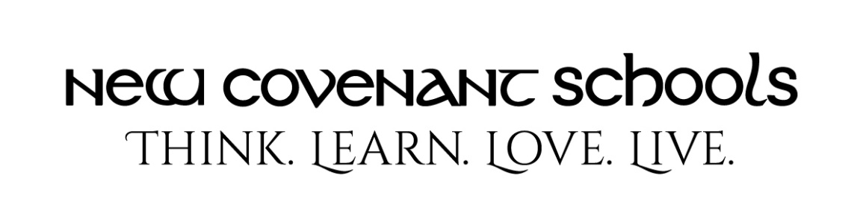

Grammar School Uniform Guide 2021-2022: K-4th Grade Girls
Monday & Wednesday (non-dress days)
- NCS light blue polo
- Flynn & O’Hara navy skort, skirt, or pants
- Solid or braided black or brown belt (if wearing pants) *
- NCS navy hooded sweatshirt or navy cardigan sweater ONLY (no Middle School Fleece, no athletic sweatshirts)
- Basic Mary Jane, black or navy (no heel); strap must go over foot not top of shoe. (NO
BALLET FLATS or SPERRY). Hush Puppies Tuft or Merrell Jungle Moc, black or brown only*
Tuesday & Thursday (dress days)
- Flynn & O’Hara white Peter Pan blouse
- Flynn & O’Hara blackwatch plaid drop waist jumper or belted tunic jumper
- NCS navy hooded sweatshirt or navy cardigan sweater ONLY (no Middle School Fleece, no athletic sweatshirts).
- Basic Mary Jane, black or navy (no heel); strap must go over foot not top of shoe. (NO BALLET FLATS OR SPERRY). Hush Puppies Tuft or Merrell Jungle Moc, black or brown only*
Friday (casual day)
- NCS gray t-shirt (ONLY)
- Flynn & O’Hara navy skort, skirt, shorts or pants
- Solid or braided black or brown belt (if wearing pants) *
- NCS navy hooded sweatshirt or navy cardigan sweater ONLY (no Middle School Fleece, no athletic sweatshirts)
- Sneakers (no lights, wheels or sound effects; must have closed toe & heels)
PE Uniform-(Beginning in 4th Grade):
- Gray NCS t-shirt, navy NCS shorts and sneakers
Alternative Shoe for Grades K-4: The official uniform shoe for Monday through Thursday are available through www.flynnohara.com. If you choose, you may purchase alternatives that look virtually the same as the shoes on their website. Suggestion: For the Mary Jane shoe you may purchase any plain, solid black or navy blue (flat) Mary Jane shoe. No ornamentation, no patent leather or velvet, no high heels.
*All uniform items must be purchased from www.flynnohara.com or the NCS Store EXCEPT items marked with an asterisk (belts, socks and shoes). The NCS store provides polos, gray t-shirt, navy hooded sweatshirt. Socks/tights must be worn each day.

