Submitting handwritten homework:
- Write out work on notebook paper.
- Stay organized!
- Support your answer with work!
- Create a .pdf of your work.
- Save as “Last Name_First Initial_Assignment”. (For Example: “Smith_T_HW3”)
- Submit in RenWeb HW Drop.

Creating a .pdf of your paper(s) using the Tiny Scanner app:
(You are free to use any app or a scanner on your printer at home.)
For the most part, this process is intuitive (I know you all are tech savvy), but you may find these instructions helpful for particular steps in the process.
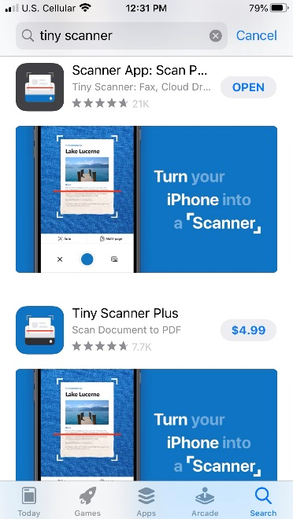
- Get a scanner app.

The following steps and screen shots use the “Tiny Scanner” App. Search for “Tiny Scanner”. There is a free and a paid version. The free version should be fine.

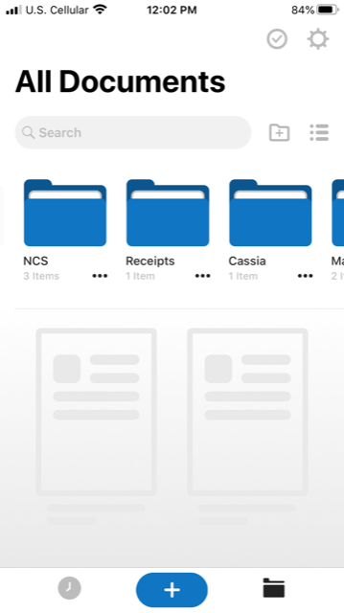
- Click the “+” to create a new .pdf.

- Take a picture by clicking the blue circle and move the corners to fit page.

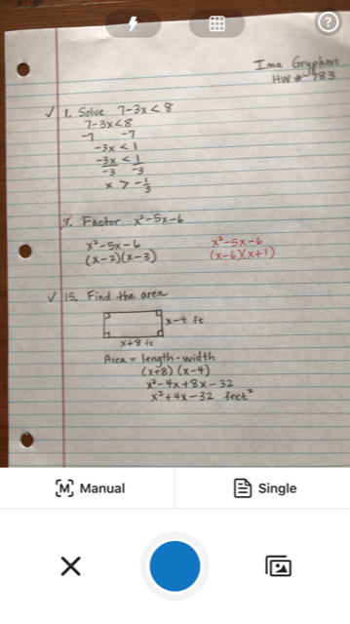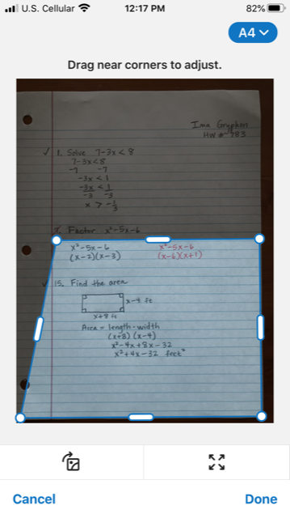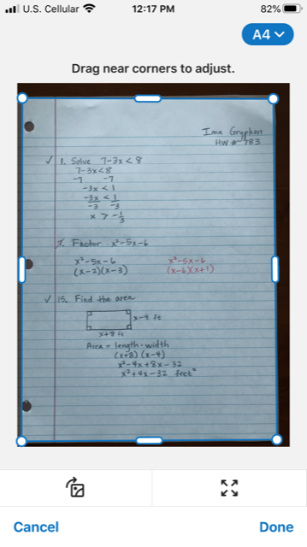

- When you click “done”, a temporary name will appear at the top of the screen. Click on that name and change it to the format “Last Name_First Initial_Assignment”. Then click “done” and “save”.
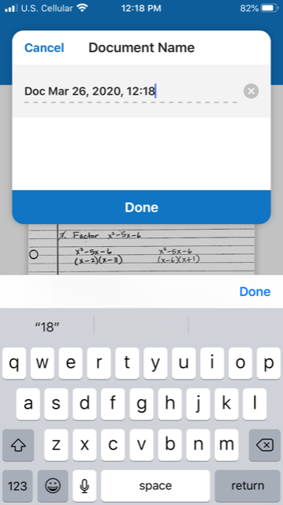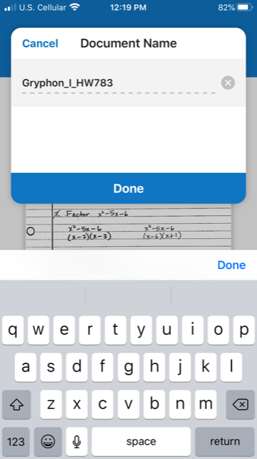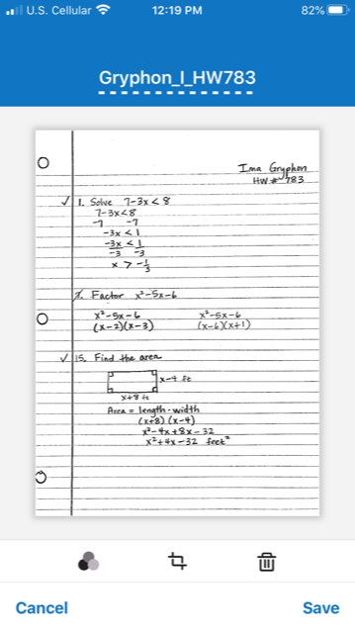

- At this point, your document is ready to email or send to your One Drive (if that’s how you want to access it on a computer). But what if you have more than one page of work on your homework or quiz? Here’s how to add a page to the same document.
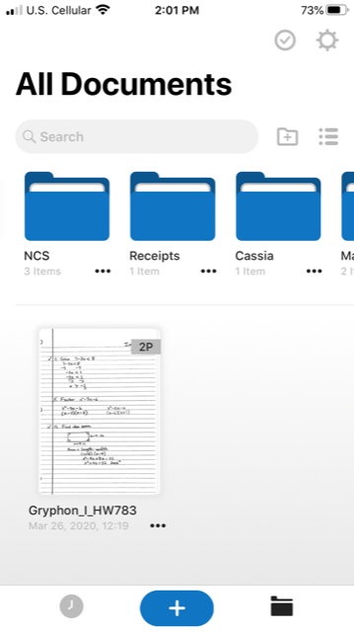
- Look in your documents.

- Click on the document that needs an extra page.

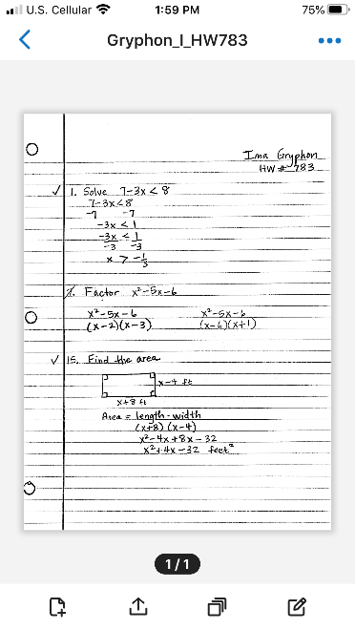
- Click on the add a page button.

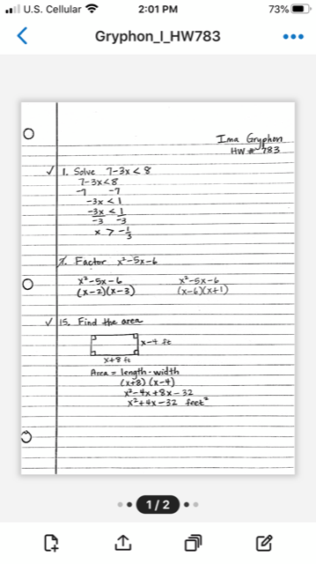
- Repeat the process of taking a picture, adjusting the corners, clicking “done”, and then “save. Once you do this, you will see that there are two pages in the document. Repeat this process until all your work for that assignment is in the same document.

- Now you are ready to submit your document. Click on the share button.

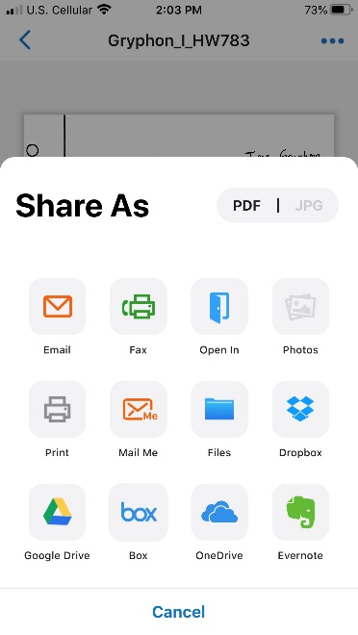
- There are many options for how to get it to a place where you can submit it on RenWeb. You could email it to yourself using either the top left email button or the Mail Me button if you want to set that up. OneDrive is available and Google Drive. Using one of these, make it so you can access the file on a computer.

- Submit the assignment in RenWeb using the HW Drop tab in our class.

